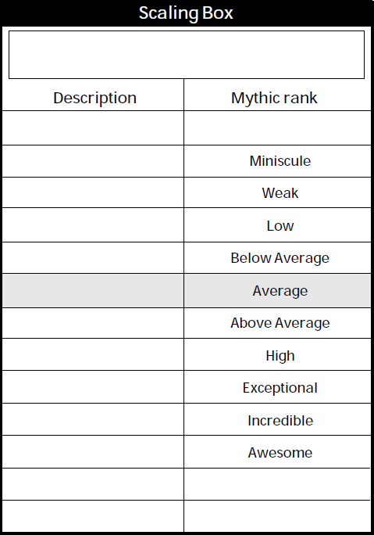

Stunning damage. -2 RS to Strength/Willpower for the duration of combat

Stunning damage. -1 RS to Strength/Willpower for the duration of combat

Stunning damage. -2 RS to Strength/Willpower for 3 character turns

Stunning damage. -2 RS to Strength/Willpower for 2 character turns

Stunning damage. -1 RS to Strength/Willpower for 3 character turns

Stunning damage. -1 RS to Strength/Willpower for 2 character turns

Stunning damage. -2 RS to Strength/Willpower for 1 character turn

Stunning damage. -1 RS to Strength/Willpower for 1 character turn

Stunning damage.

Stunning damage.

Poison Effects















